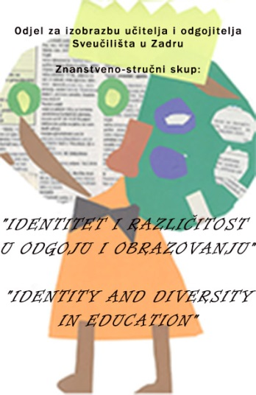
Identity and Diversity in Upbringing and Education
Scientific and expert meeting with international participation
SECOND ANNOUNCEMENT
Organizer:

University of Zadar, Department of Teacher and Preschool Teacher Education

Zadar, 21st to 23rd September 2017.
Department of Teacher and Preschool Teacher Education
New campus, Franjo Tuđman street 24 i, Zadar

Dear Colleagues,

Department of Teacher and Preschool Teacher Education, after the successful completion of the last year's meeting The Modern Approach to Upbringing and Education of Children and Students organizes a scientific and expert meeting with international participation, as a kind of continuation, Identity and Diversity in Upbringing and Education.

The gathering will be supported by a large number of eminent scientists from the field of education, with the aim of attracting a number of interesting expositions of identity and diversity, once again we are inviting you to participate.

Except for the presentation, you can also sign up as a listener to expand your knowledge of the current issue of diversity.

The target group: employees from the system of early and pre-school and primary education (educators, teachers, professors, professional associates), employees from the health care system, employees of the social welfare system, university teachers and researchers, volunteers from non-governmental organizations and others.

Forms of work or participation: plenary lectures, presentations in sections, work in workshops, book presentations, an exhibition of posters and picture books.

Note:

Participants who have already signed up for oral presentation and have not submitted summaries in Croatian and English, please send them within the specified deadline so that we can conduct the review process and notify them in a timely manner of accepting the summaries.

All summaries received so far are in the review procedure and the authors will receive the notification by mail.

We are looking forward to your arrival!

Organizational committee

Instructions for participation:
- The application exclusively by link: https://goo.gl/forms/USCarIzRSxJUxtBx1
until June 1, 2017.
- Payment of registration fee until July 1, 2017.

- Registration fee for the conference in the amount of 500,00 HRK (for conference working materials, conference proceedings and participation in two workshops) has to be paid on the account of the University:
- IBAN: HR53 2330 0031 1001 63243
- Model HR00 Notification No.65000-ID of participant
(with an indication of fee for scientific conference Identity and Diversity in Upbringing and Education).

The participants will receive an official certificate of attendance at
Scientific and expert meeting
Department of Teacher and Preschool Teacher Education, University of Zadar

(http://www.unizd.hr/ucitelji-odgojitelji/Znanstveniskup2017/tabid/5597/Default.aspx

- All additional information can be obtained by e-mail: adelic@unizd.hr i ematassi@unizd.hr

- Delivery of the article title and summary

The summary should contain a brief summary of the article specifying the objective of the research, the most important results and conclusions which will be presented (up to 200 words). The abstract should include five key words that are not represented in the title. In addition to a summary in the Croatian language should be submitted a summary in English language.

- Deadline for submission of the summary: until June 15, 2017. (by web link of Department of Teacher and Preschool Teacher Education, University of Zadar )

- Notification of summary acceptance: until June 25, 2017.

- Delivery of the paper: until July 15, 2017. (by web link of Department of Teacher and Preschool Teacher Education, University of Zadar )

Instructions for the preparation of papers:

Two independent reviewers will evaluate each submitted work. Depending on the reviewing procedure, the work will be categorized.

The article should be submitted in the following format: A4, 3 cm margins, font size 12 pt, font type Times New Roman, line spacing 1.5.

The extent of article, including the summary, references and graphic attachments should not exceed 16 pages of text.

Graphics contributions should be clean, sharp and clearly visible to enable reproduction. The author should mark the spot where the graphics stand.

A summary of up to 200 words (ten lines) should indicate the purpose of the article, the main results and conclusions. At the end of the summary, under the "keywords" should be written an alphabetical list of the most important key terms discussed in the text, up to five (5) words.

