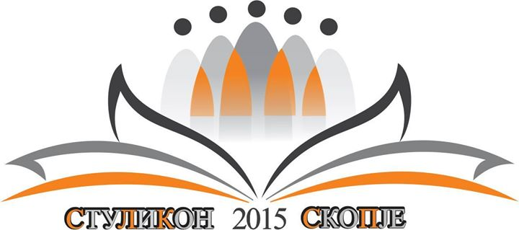

Fourth Student Linguistic Conference
StuLiKon

24-26 april 2015

Faculty od Philology ,,Blazhe Koneski”, ,,Sts. Cyril and Methodius” University – Skopje, R. Macedonia

Web: www.stulikon.mk
Facebook: facebook/Stulikon2015
E-mail: apstrakti@stulikon.mk stulikon2015@stulikon.mk

Call for participation

Dear all,

It is with great pleasure that we invite you to the fourth students’ linguistic conference – StuLiKon, (previously held in Belgrade, Zagreb and Sarajevo) which will take place at the Faculty of Philology Blaze Koneski in Skopje from the 24th until the 26th of April, 2015.

All undergraduate and graduate students with majors in philological studies are eligible for participation.

The topics of research can range from the following fields:
phonetics and phonology
morphology
lexicology
syntax
semantics
pragmatics
applied linguistics as well as other language disciplines.
Candidates can do single research papers or coauthor papers written in any of the South Slavic languages or in English.

The abstracts should be sent to the following email address: apstrakti@stulikon.mk. The detailed instructions concerning the writing of the abstracts can be found on our web page www.stulikon.mk or on our Facebook page Facebook/Stulikon 2015. All other questions concerning the conference can be sent to the following email address: stulikon2015@stulikon.mk

Participants are not required to pay for the participation, and all applicants will receive the feedbacks for their abstracts in February.

We eagerly await your participation in the conference, StuLiKon organizing
committee, 2015

