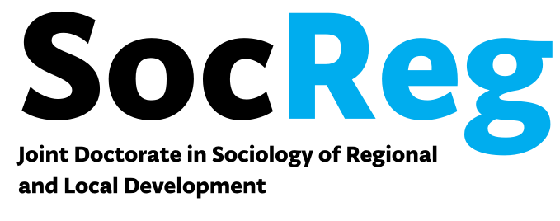
------------

University of Zadar (HR) - University of Teramo (I)

(Local convenor: Emilio Cocco, ecocco@unite)

University of Teramo
Faculty of Communication Science

Teramo, 26 May 2016

Introduction and
Session 1 (aula 6)

9.00-9.15 Opening and address by the Dean of the Faculty of Science of Communication, University of Teramo prof. Stefano Traini

9.15-10.45 Research Design: Lecture

Saša Božić (University of Zadar)

10.45-11.00 Break

11.00-13.00 Research Design: Workshop

Session 2 (seminar room, communication science)

14.30 – 16.00
Qualitative Research Methods

Valerija Barada (University of Zadar)

16.00-16.15 Break

16.15-17.45
A spectrum of regionalities

Vjeran Katunarić (University of Zadar)

17.45-18.00 Break

Session 3 (seminar room, communication science)

18.00-19.00 Discussion on the use of qualitative methods in doctoral research designs

Teramo-Medoro-Atri 27 May 2016

Session 4 (seminar room, communication science)

9.00 – 10.30

Quantitative Research Methods

Zvjezdan Penezić (University of Zadar)

Field Session 1
(Villamedoro winery, Medoro, TE)

11.30-12.30

Local and international development: The “Villamedoro” winery case.
Alessia Di Giovacchino (Media & PR manager - Co-founder of "Una domenica fuori porta")
Federica Morricone (winery holder and manager)

Session 5
(Atri, Town Hall)

14.30-16.30

Rural development strategies and field-work research.

Rita Salvatore (University of Teramo)

16-30-17.30

Discussion on the use of quantitative methods and fieldwork in doctoral research designs

17.30-18.30

Visit to archaeological sites in Atri.

Pescara, 28 May 2016

Field Session 2
(Pescara, waterfront/lungomare)

10.00-12.00

Remaking the waterfront. Politics of urban regeneration in Pescara

Emilio Cocco, Rossella di Federico (University of Teramo) Giovanni Di Iacovo (Cultural Policy Counsellor, Pescara Town Council)

